Help!
Powers
Name: ___________________________
3² = 3 x 3 = 9
3³ = 3 x 3 x 3 = 27

- Write the following in index form:

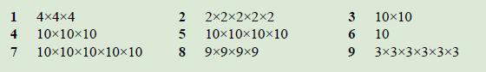

- Write the following in factor form:

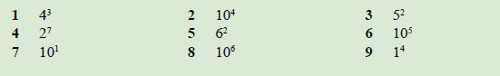

- Evaluate each of the following square and cube numbers

- 3²
- 6²
- 9²
- 4³
- 2³
- 5³

- Challenge: Calculate each of the following:

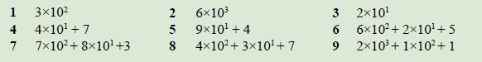

Space for working and answers:

Extension:

A) Try the following questions:

- 2² x 2³ =

- 3² x 3² =

- 2² x 2⁴ =

- 4² x 4² =

- 3³ x 3² =

- 2² x 2³ =

B) Looking back at your answers, can you find a general rule for how to multiply powers? Explain:

________________________________________________________________________________________________________________________________________________________________________________________________________________________
________________________________________________________________________

C) Using the rule you have now found, how could you evaluate:

- 27³ x 27⁷ =

- 105⁴ x 105⁵ =

- 78⁴ x 78⁷ x 78⁵ =

D) Can you find a rule to evaluate dividing powers? e.g. 2⁵ ÷ 2³ =

________________________________________________________________________________________________________________________________________________________________________________________________________________________
________________________________________________________________________
________________________________________________________________________________________________________________________________________________

